**Problem Definition:**

Know your client (KYC) is a guideline for the banking system to validate a customer using identity, appropriateness, risk assessment in establishing a banking relationship. With the growing concern of security, the KYC process is complex and involves a high cost for completing for a single customer.

# Objectives:

1. To Secure and faster for sharing sensitive information.
2. To allow customer and business institute to verify record customer record.
3. To allow third party verification.
4. More Secure due to block chain.

# Relevant Theory (Existing System) :

Know your client (KYC) is a guideline for the banking system to validate a customer using identity, appropriateness, risk assessment in establishing a banking relationship. With the growing concern of security, the KYC process is complex and involves a high cost for completing for a single customer.Sharing of confidential KYC data must be authorized by customers, and a bank-customer relationship must be kept secret from network.

**System Design :** (Architecture of proposed system)

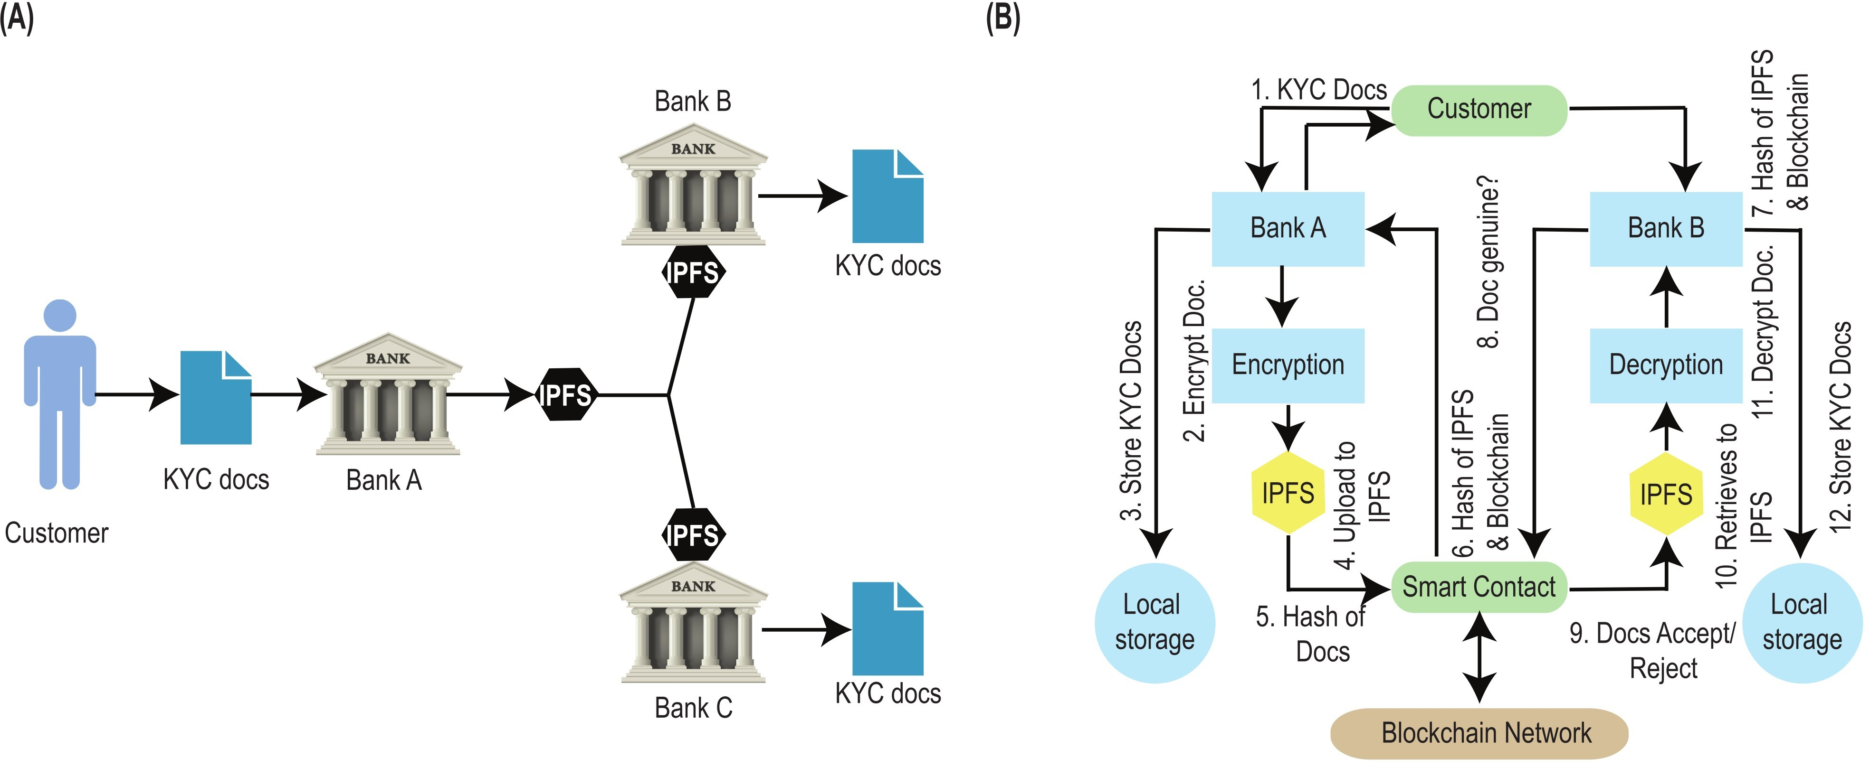

**Fig. 1 : PROPOSED SYSTEM**

In our proposed system we are sharing kyc documents with blockchain so user document and details keep safe and secure.

In above architecture we can see we have created one secure IPFS system so user here kept their documents and details.

In Second part when user required to done transaction from one bank to other bank that time our system will help to provide easy KYC to send amount easily and securely.

In Diagram we can see there is strong security algorithm so on one side we are doing encryption and other side doing decryption.

**Implementation Details (Modules) :**

1. Register
   * Here user can register and user info will be encrypting using blockchain here on portal.
2. Login
   * Login Here
3. Upload Documents.
   * User Can Upload documents in IPFS with encrypt.
4. Bank to Bank Transfer
   * Show bank to bank transfer also check kyc if amount greater than 1 lakh

# Working of Proposed System :

An important class of applications requires data to be shared selectively among mutually anonymous transacting peers while retaining the tamper-resistant evidentiary and validation features of a blockchain. KYC validations of corporate customers by banks.Economical, swift, secure, and transparent platform for KYC document veriﬁcation for the Banking system through InterPlanetary File System (IPFS) and blockchain technology. The proposed system allows a customer to open an account at one Bank, complete the KYC process there, and generate a hash value using the IPFS network and share it using the blockchain technique. we describe the design and implementation of a smart contract for consent-driven and double-blind data sharing on the Hyperledger Fabric blockchain platform. We show how a KYC application was built around this model to address the needs of the banks

# Algorithm:

• Step 1: A customer provides private data to one of the service providers off the blockchain network.

• Step 2: The provider processes the data, adds attributes and metadata, and submits it to the blockchain for validation and recording.

• Step 3: The replicated contract application validates the data and the authority of the provider to submit it before approving it for recording through consensus.

• Step 4: When another service provider needs to read or refresh data, it accesses its copy of the distributed

ledger. The customer does not need to resubmit the data nor does the provider need to reprocess it.

In a conventional blockchain, Steps 2 and 3 would reveal a customer-provider relationship, and automatic access to

data (Step 4) would violate the customer consent rule

# Minimum Requirement:

1. **Software**:
   1. Windows 7 and above
   2. Language : Jsp and Servlet

# Hardware:

* 1. Processor : Minimum i3 and above
  2. RAM : 1 GB or above
  3. HDD : 256 GB or more

# Applications :

1. Access control system for digital contents distribution.
2. Media Database Systems.
3. Can be used to hide a secret chemical formula or plans for a new invention.
4. Though attempts have been made to provide privacy for cryptocurrency and some types of smart contracts

# Conclusion:

Blockchains represent the future of transactions and are beginning to transform entire industries. Consequently, there is considerable interest in exploring blockchains for various industry use cases. They are particularly useful in supporting multi-party business transactions where the entities need not trust each other. The immutable, cryptographically secured, and replicated, ledger, consensus to validate transactions, and permissioned access are all attractive salient attributes for enterprises to consider blockchains as the future transaction network.

# References:

1. Implementation of Least Significant Bit Image Steganography with Advanced Encryption Standard Adit Pabbi;Rakshit Malhotra;K Manikandan 2021 International Conference on Emerging Smart Computing and Informatics (ESCI) [2021]
2. A. Kosba, A. Miller, E. Shi, Z. Wen, and C. Papamanthou, “Hawk: The Blockchain Model of Cryptography and Privacy-Preserving Smart Contracts,” IEEE Symposium on Security and Privacy, 2016,pp 839-858. “Consumer Digital Identity: Leveraging Distributed Privacy Enhancing Technology,” (White Paper: Secure Key):https://securekey.com/resources/consumer-digital-identity/

[3] E. Ben-Sasson, A. Chiesa, C. Garman, M. Green, I. Miers, E. Tromer, and M. Virza, “Zerocash: Decentralized Anonymous Payments from Bitcoin,” IEEE Symposium on Security & Privacy (Oakland) 2014,pp 459-474, IEEE, 2014.

[4] C. Garman, M. Green, and I. Miers, “Accountable privacy for decentralized anonymous payments”, International Conference on Financial Cryptography and Data Security (Barbados), pp. 81-98,2016.

[5] “Zero-knowledge Security Layer to be Added to Quorum Blockchain Platform”, Press Release: https://z.cash/blog/zsl-quorum.html

[6] A. M. Antonopoulos, “Mastering Bitcoin: Unlocking Digital CryptoCurrencies” (1st ed.). O'Reilly Media, Inc., 2014.

[7] “A Next-Generation Smart Contract and Decentralized Application Platform” (Whitepaper):https://github.com/ethereum/wiki/wiki/White-Paper

[8] “What it means to ‘Know Your Customer’”: https://complyadvantage.com/knowledgebase/kyc/

[9] M. Castro and B. Liskov, “Practical Byzantine Fault Tolerance”, In Proceedings of the Third Symposium on Operating Systems Design and Implementation (OSDI '99). USENIX Association, Berkeley, CA,USA, 173-186, 1999.

[10] N. Garg, “Apache Kafka. Packt Publishing”, 2013.

[11] “IBM Blockchain Platform”: https://console.bluemix.net/docs/services/blockchain/index.html#ibmblockchain-platform

[12] “Hyperledger Fabric v0.6.1: Protocol Specification”: https://github.com/hyperledger/fabric/blob/v0.6.1-